

**Safety of Electromechanical systems**

**Dr. Mohamed Zakaria**

**Safety devices**

|  |  |
| --- | --- |
| ID | Name |
| 4715 | Ibrahim Mostafa Elshenhapy |
| 4658 | Ahmed Nasser Zaki Elsayed Elshennawy |
| 4944 | Hamza Hammad Hafez |
| 4667 | Abdelrahman Ahmed Elsayed |
| 4550 | Mohamed Ahmed |

**Abstract**

Protection of electrical circuits is very important in electrical systems as any fault current can cause huge losses for industries in terms of safety and productivity. Circuit protection devices are used to protect users and equipment from fault conditions in an electrical circuit by isolating the electrical supply. In this report, we will explain briefly the main two circuit protections devices: **Overcurrent protection devices** and **Residual Current devices,** and their types.

Overcurrent protection devices are used to protect against the potentially dangerous effects of overcurrent, which creates a fault current. When an overcurrent occurs, these devices break the circuit eliminating the current flow. Fuses and circuit breakers are the most common types of overcurrent protection devices. Fuses can be quicker for interrupting the flow of power, but when they melt they must be replaced; on the other hand circuit breakers just need to be reset.

Residual Current devices are designed to protect against the risks of electric shocks and fire caused by earth faults. There are various types of RCDs that can be used to offer high performance and protection. These devices offer a level of personal protection that ordinary fuses and circuit breakers cannot provide.

**Table of Contents**

**INTRODUCTION** 3

**I.** **OVERCURRENT PROTECTION DEVICES:** 4

**1. Fuses:** 4

Theory of operation 4

Types of Fuses 5

DC Fuses 5

AC Fuses 7

Features of a Fuse 9

Applications of Fuses 10

**2. Circuit Breakers:** 11

Theory of operation 11

Types of Circuit Breakers 11

Low Voltage Circuit Breakers 12

Medium Voltage & High Voltage Circuit Breakers 13

Applications of Circuit Breakers 15

Criteria in choosing the Circuit Breaker 16

Calculating a safe circuit load 16

Selection Table 17

Circuit Breaker Manufacturers 17

**II.** **RESIDUAL CURRENT DEVICES** 18

Theory of operation 18

Types of Residual Current Devices 19

1. RCCB (Residual Current Circuit Breaker) 19

2. RCBO (Residual Current Breaker with Overload) 19

3. ELCB (Earth Leakage Circuit Breaker) 20

Sensitivity 20

Limitations 20

Importance in electrical circuits 20

Applications of Residual Current Devices 21

Installation types 21

Installation considerations 22

Selection table 22

**CONCLUSION** 23

**REFERENCES** 24

**Safety devices**

# **Introduction**

An electrical system is built with great care to ensure that each separate electrical circuit is completely isolated from the others and that the current in a circuit will flow in its intended path. However, once the system is put into operation, many things can happen changing the original circuitry. Some of these changes can cause conditions that are dangerous to the circuit itself or to people living or working near the circuits. For this reason, circuit protection is required to avoid these potentially dangerous conditions. Although circuit protection devices cannot correct an abnormal current condition, they can indicate that an abnormal condition exists and protect people and circuits from that condition.

Circuit protective devices, as the name implies, all have a common purpose to protect users and equipment from fault conditions in an electrical circuit by isolating the electrical supply. As the technologies are getting improved, various devices are getting introduced, but the major two circuit protection devices are **Overcurrent protection devices** and **Residual Current devices**.

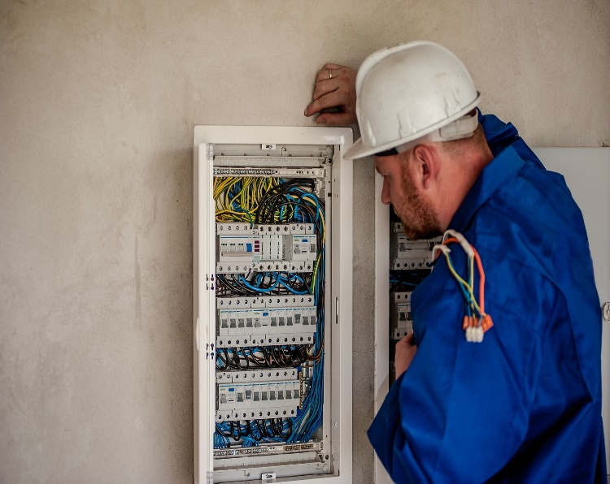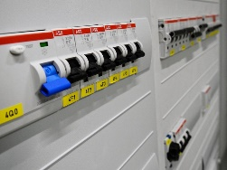

# **Overcurrent protection devices:**

Overcurrent is an excess of current in an electrical circuit which occurs when the current exceeds the rated current capacity of that circuit or of the connected equipment. Overcurrent protection devices (OCPDs) are used to protect against the potentially dangerous impacts of overcurrent, such as an overload current or a short-circuit current, which creates a fault current.

There are many different types of OCPDs that are used to protect equipment and circuits from overcurrent. The most common types are **fuses** and **circuit breakers**. Both devices interrupt the flow of a current but in different ways from each other.

## Fuses:

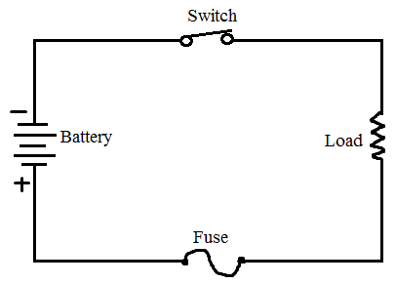Fuses are safety devices, used to protect home appliances such as refrigerator, televisions, computers from damage by high voltage. It works as a circuit breaker or stabilizer which protects the device from damage.

A fuse is made up of thin strip or strand of metal such as aluminum, copper, zinc. It is always connected in series with the component(s) to be protected from overcurrent, as shown in the opposite circuit.

### Theory of operation

The fuses work on the principle of the heating effect of current. When an excessive current flows in the circuit, it generates heat in the circuit that causes the fuse to melt due to its low melting point, and it opens the circuit. The excessive flow of current may lead to the breakdown of the circuit and stops the current flow. Once the fuse melts, it can be replaced with a new one.

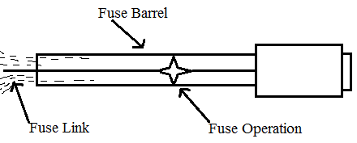

### Types of Fuses

There are many types, features, and designs of fuses available in the market nowadays. They can be divided into two major categories: AC fuses, and DC fuses. The below block diagram illustrates the different types of the fuse under each category.

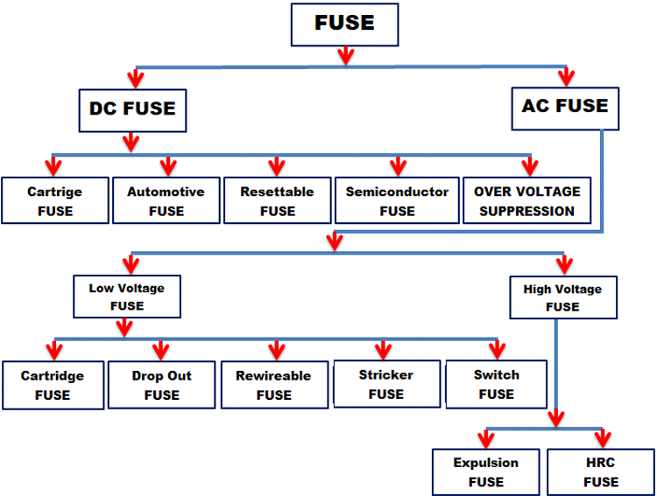

### DC Fuses

#### Cartridge fuses

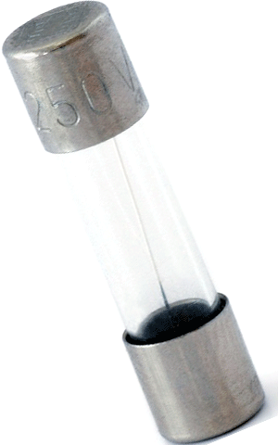This is the most common type of fuse. The fuse element is encased in a glass envelope that is terminated by metal caps. The fuse is placed in an appropriate holder. Since the glass envelope is clear, it is easy to visually determine if the fuse is blown.

#### Automotive fuse 32V ATO typeAutomotive fuses:

These fuses are specifically designed for automotive systems that run up to 32V and occasionally 42V. They come in ‘blade’ form (a transparent plastic envelope with flat contacts) and are colour coded according to rated current. Some of these types are also used in other high-power circuits.

#### Resettable fuses/Poly fuses:

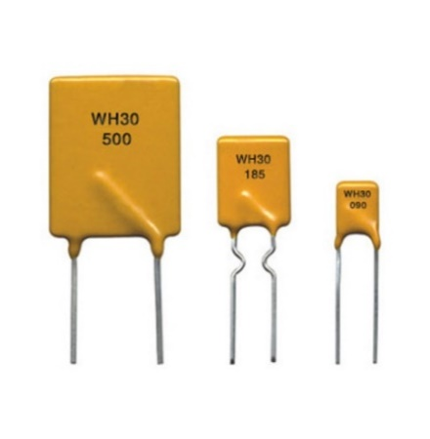These fuses are self-resetting. They contain carbon black particles embedded in organic polymers. Normally, the carbon black makes the mixture conductive. When a large current flows, heat is generated which expands the organic polymer. The carbon black particles are forced apart, and conductivity decreases to the point where no current flows.

Conductivity is restored as temperature decreases. Thus, the fuse does not have to be physically replaced. This kind of fuse is also called “positive temperature coefficient PTC”, since resistance increases with temperature.

#### Semiconductor fuses

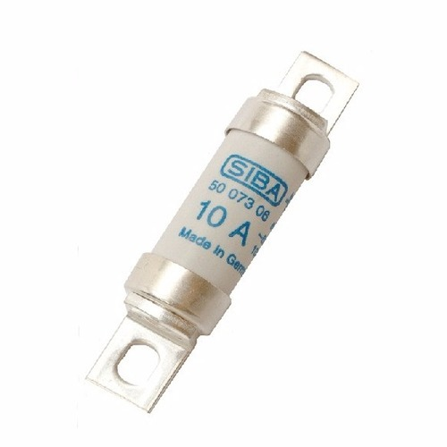The power dissipated by a semiconductor increases exponentially with current flow, and hence semiconductors are used for ultrafast fuses. These fuses are usually used to protect semiconductor switching devices that are sensitive to even small current spikes.

#### Overvoltage suppression

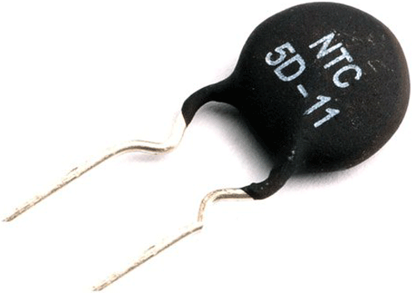Sometimes voltage spikes can be harmful to circuits too, and often an overvoltage protection device is used with a fuse to protect against both voltage and current spikes.

NTCs (negative temperature coefficient) are placed in parallel with the supply. When the supply voltage spikes, NTC Fuses decrease resistance due to higher current flow and ‘absorb’ spikes.

### AC Fuses

#### Low voltage fuses (LV)

These fuses are used in the relatively low voltage distribution networks.

##### Cartridge fuses

 They are very similar to cartridge DC fuses. They consist of a transparent envelope surrounding the fuse element. They can be plugged in (blade type) or screwed into a fixture (bolt type).

##### Drop out fuses

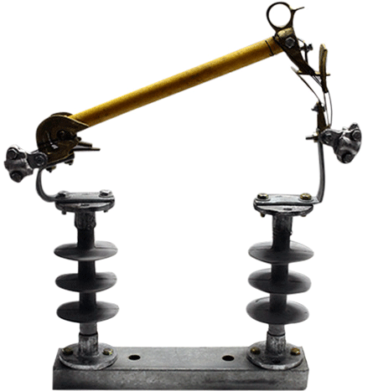They contain a spring-loaded lever arm that retracts when a fault occurs and must be rewired and put back in place to resume normal operation. They are a type of expulsion fuse.

##### Rewireable fuses

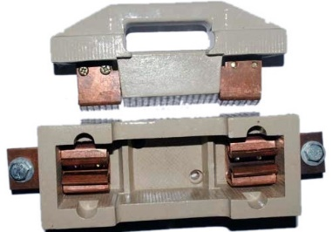They are a simple reusable fuse used in homes and offices. They consist of a carrier and a socket. When the fuse is blown, the carrier is taken out, rewired and put back in the socket to resume normal operation. They are somewhat less reliable than HRC fuses.

##### Striker FusesStriker fuse:

These fuses are provided with a spring-loaded striker that can act as a visual indicator that the fuse has blown and also activate other switchgear.

##### **Switch fuse**

A handle that is manually operated can connect or disconnect high current fuses.

#### High Voltage Fuses (HV)

These fuses are used in high voltage AC transmission lines where voltages can exceed several hundreds of kilovolts. All types of high voltage fuses are used upon the rated voltage up to 1.5 Kv to 138 Kv.

##### HRC Fuses

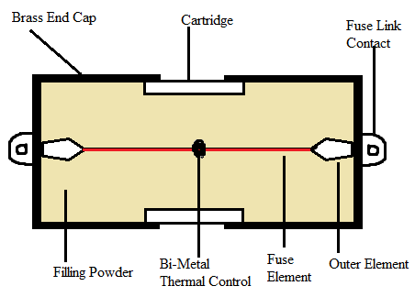It is similar to low voltage type, only some designing features are different.

##### Expulsion Type HRC Fuses:

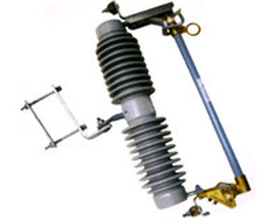 It is the escapable fuse, in which expulsion effect of gases produced by internal arcing. In this, the fuse link chamber is filled with boric acid for expulsion of gases.

### Features of a Fuse

There are some important parameters that must be considered while selecting suitable fuses which are:

1. Current Rating
2. I2T value
3. Voltage Rating
4. Operating Temperature

#### Current Rating:

This is the current carrying capacity of a fuse measured at normal conditions and temperature. Before adopting this technique, one must make sure that circuit components are able to withstand the overload of current before the fuse act its role. Therefore, whenever there is a sudden increase of current, only the fuse will blow out.

The circuit’s current generally should be 75% of your fuse’s current rating.

#### I2T Value of Fuse:

This is also called as “melting current”, when the current increases in the circuit, the melting time of the element decreases. This is because the power dissipation and the temperature increase rapidly. In short, the product of square of the current in the circuit should be less than I2T value of the device.

**I2T Circuit= I2T Device**

#### Voltage Rating:

Voltage rating for the Fuses are mainly considered for safety reasons for the circuit as well as the environment. It is because an explosion may take place and might trigger fire if the open circuit voltage is higher than that of the device when fuses open up.

#### Temperature:

Temperature affects the capacity of Fuses. When the operating temperature is high, the current capacity will decrease and it melts early. Hence, the current capacity in the fuse is directly proportional to the operating temperature

### Applications of Fuses

The applications of Fuses include nearly all electrical/ electronic devices such as:

* Electrical wiring at home.
* Appliances like AC, Refrigerator, TV, Washing machine etc.
* Laptops.
* Mobile chargers.
* Automobiles (Cars, Trucks, Buses, etc).

## Circuit Breakers:

The main duty of a Circuit Breaker is to switch ON and OFF the electrical circuits during normal or abnormal operating conditions, once or several times repeatedly.

### Theory of operation

A typical circuit breaker consists of a fixed and a moving contact called Electrodes. These contacts are closed under normal conditions. If a fault occurs in the system, the contacts will open automatically and they can be opened manually. During fault conditions, a simple mechanism will pull the moving contacts away as a result of trip coil getting energized and essentially opening the circuit.

### Types of Circuit Breakers

Circuit breakers are mainly categorized on the basis of application as per voltage:

**Low Voltage Circuit Breakers**

* Molded Case Circuit Breaker (MCCB)
* Air Circuit Breaker (ACB)
* Miniature Circuit Breaker (MCB)
* Motor Protection Circuit Breaker (MPCB)

**Medium Voltage Circuit Breakers**

* Vacuum Circuit Breaker (VCB)
* SF6 Circuit Breaker

**High Voltage Circuit Breakers**

* SF6/Vacuum Circuit Breaker
* Oil Circuit Breaker (OCB)

### Low Voltage Circuit Breakers (operates up to 1KV)

#### Molded Case Circuit Breaker (MCCB):

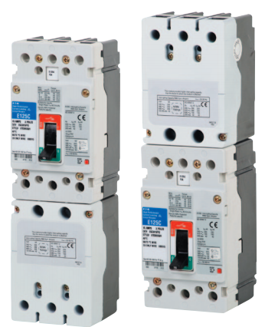MCCB is a kind of circuit breaker which is enclosed in the molding or housing of a moulded material and that is the reason for its name. It is generally used for the current ratings up to 1600A and fault level up to 150KA. It offers protection against overload and short circuits through bimetal and solenoid, these days Microprocessor based MCCBs are being very popular due to the quick functioning of their electronic type release.

**Applications:**

These breakers are most commonly applied when very high fault levels are available and with applications where the current limiting capability is used upstream of the final load to limit current to the load. Typical loads include lighting and power distribution, and motor controller applications.

#### Miniature Circuit Breaker (MCB):

MCB is a circuit breaker which is used for protection where current ratings are lower. It can be used up to 125A circuits and like MCCBs it also offers protection against overload and short circuit through bimetal and solenoid. These days Class 3 MCBs are very popular due to their ability of tripping quickly and also minimum loss of let through energy.

#### Air Circuit Breaker (ACB):

ACB as the name suggests it’s the circuit breaker where the medium of arc quenching is air. ACB is used for the high current applications, or we can say that ACB can offer protection against overload & short circuit up to 6300A. Tripping in ACB is achieved through release. The release is known as the mind of ACB as it only suggests the ACB to trip in case of fault.

#### Motor Protection Circuit Breaker (MPCB):

MPCBs are used specially for motor protections. MPCB as a standalone device offers protection against Overload, Short Circuit and Single Phasing, thus it is used specifically for motor applications.

### Medium Voltage & High Voltage Circuit Breakers

* Medium Voltage Circuit Breakers operates in a range from 1KV to 69KV
* High Voltage Circuit Breakers operates in a range from 69KV to 230KV

#### Vacuum Circuit Breaker (VCB):

VCB is used for Medium Voltage applications. In VCB the contacts operation & arc quenching takes place inside bottles where Vacuum is present.

[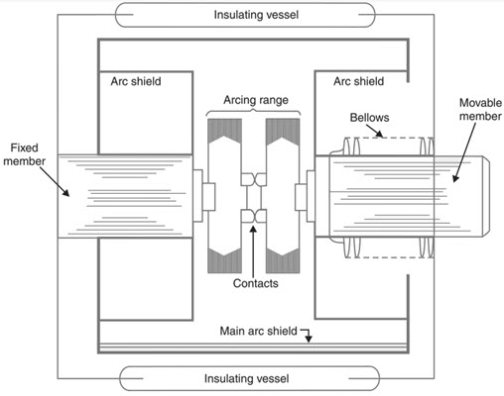](https://www.electronicshub.org/wp-content/uploads/2019/05/Different-Types-of-Circuit-Breakers-Vacuum-Circuit-Breakers-VCB.jpg)**Advantages:**

* No fire hazards.
* Compact, very reliable and have very long life.
* No gas is generated during or after operation.
* No or very little maintenance.
* VCB can interrupt any fault current.
* Can withstand lightning strikes.
* Low arc energy is released.

#### SF6 Circuit Breaker:

[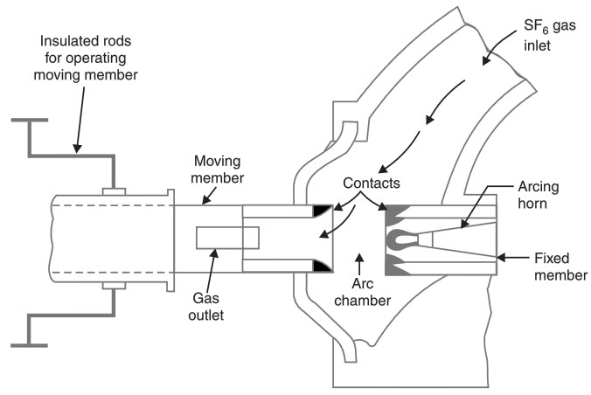](https://www.electronicshub.org/wp-content/uploads/2019/05/Different-Types-of-Circuit-Breakers-Sulphur-Hexafluoride-Circuit-Breakers.jpg)SF6 circuit breakers are also used mainly in medium voltage applications. In this breaker SF6 gas is used for arc quenching due to its ability of quenching the arc very efficiently. SF6 Breakers being highly efficient in arc quenching are still not preferred much as SF6 being a poisonous gas, is dangerous to environment & humans.

**Advantages:**

* Superior arc extinguishing property.
* Can interrupt larger currents as the dielectric strength of SF6 gas is almost 3 times greater than air.
* Noise free operation and no exhaust into atmosphere.
* Moisture free operation as the gas filled chamber keeps in interior dry.
* Very low maintenance and requires minimum equipment.
* Suitable for hazardous and hostile conditions like coal mines as the breakers are enclosed and sealed.

**Disadvantages:**

* Sulfur hexafluoride gas is very costly.
* SF6 has to be reconditioned after every operation.
* This high-pressure Sulfur hexafluoride gas will absorb all the conducting free electrons and as a result causes the extinction of the arc.

#### Oil Circuit Breaker:

[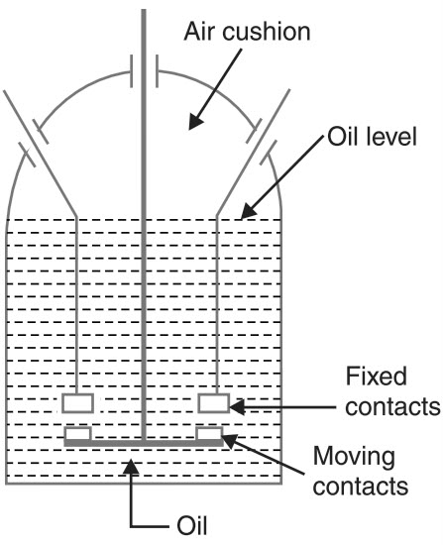](https://www.electronicshub.org/wp-content/uploads/2019/05/Different-Types-of-Circuit-Breakers-Plain-Break.jpg)Oil Circuit Breakers were also used on high voltages & Oil was used as the arc quenching medium.

**Advantages:**

* Oil has excellent cooling property and the arc energy converts the oil into gas.
* Acts as insulator between live wires and earth.

**Disadvantages:**

* Oil is inflammable and is a fire hazard.
* Arcing products cannot escape and remain in the oil.

### Applications of Circuit Breakers

* They are used for switching of loads in Industries, Buildings, Commercial complexes, Hotels etc.
* Air C/B is used for the protection of plants, electrical machines, transformers, capacitors and generators.
* Air Blast C/B is used in Indian Railways for electrification.
* Thermal and Magnetic Protection

### Criteria in choosing the Circuit Breaker

* Electrical characteristics (AC or DC) of the installation for which the CB is intended
* Its environment: ambient temperature, in a kiosk or switchboard enclosure, climatic conditions, etc.
* Presumed short-circuit current at the point of installation
* Characteristics of the protected cables, busbar, busbar trunking system and application (distribution, motor...)
* Co-ordination with upstream and/or downstream device: selectivity, cascading, coordination with switch disconnector, contactor...
* Operational specifications: requirements (or not) for remote control and indication and related auxiliary contacts, auxiliary tripping coils, connection
* Installation regulations; in particular: protection against electric shock and thermal effect
* Load characteristics, such as motors, fluorescent lighting, LED lighting, LV/LV transformers

### Calculating a safe circuit load

You first must add up the current of all the devices on the circuit that are on continuously, you just divide this number by the voltage at which it operates, which is either 120 volts or 240 volts.

Then, multiply this number by 125 percent. The rating of your circuit breaker must be larger than this total.

You want your circuit to be operating at 80 percent of capacity, which is called the safe load. You can calculate a safe load for a circuit breaker by multiplying its amperage by 0.8. A circuit can operate at a higher percentage, but not for long periods of time as this can compromise safety.

### Selection Table

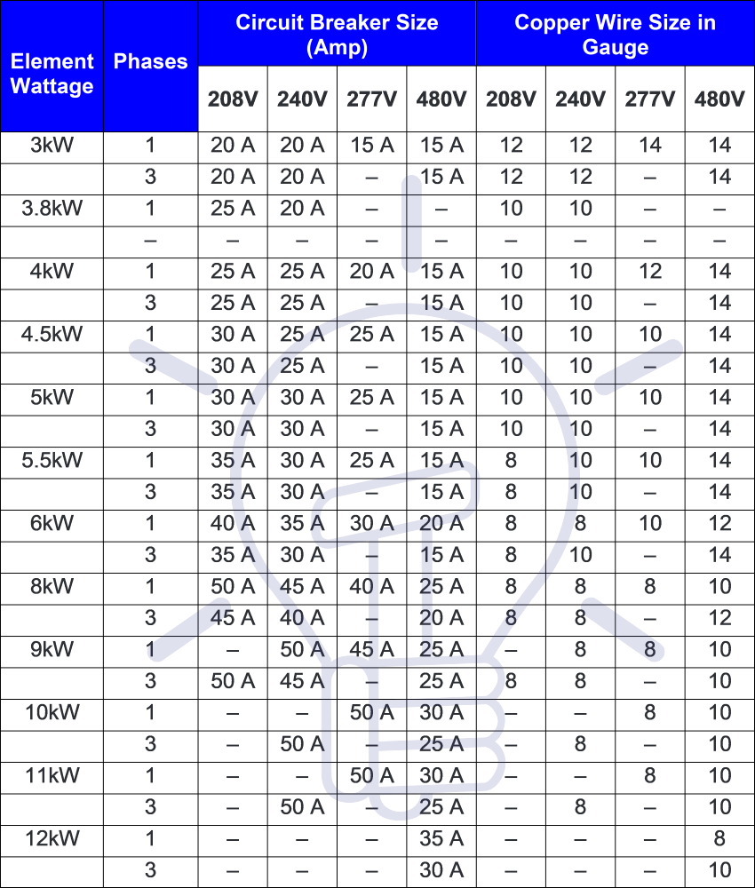

### Circuit Breaker Manufacturers

* General Electric – GE
* Westinghouse
* Cutler-Hammer
* Siemens – Allis Chalmers
* ABB – BBC – Gould – ITE
* Federal Pacific
* Square D
* PACS Industries

The Consumer Product Safety Commission (CPSC) estimates the life expectancy of a circuit breaker to be around 30 to 40 years, and it's the same for the GFCI, AFCI, and standard breakers. Because a breaker is a mechanical device, humid conditions or corrosive atmospheres will shorten the life span.

# **Residual Current Devices:**

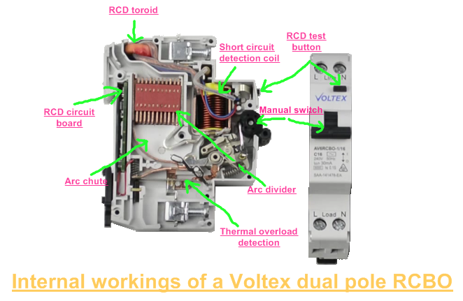The RCD is an electrical safety device that quickly and automatically breaks an electrical circuit to prevent you from getting a fatal electric shock if you touch something live. It also helps in reducing the risk of electrical fires caused by earth faults. RCDs offer a level of personal protection that ordinary fuses and circuit-breakers cannot provide, Due to its high sensitivity.

## Theory of operation

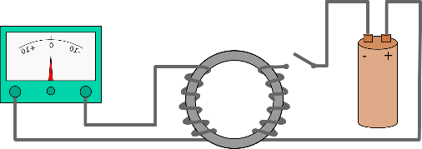It has a very simple working principle based on [Kirchhoff’s Current Law](https://www.electrical4u.com/kirchhoff-current-law-and-kirchhoff-voltage-law/) where the incoming [current](https://www.electrical4u.com/electric-current-and-theory-of-electricity/) in a circuit must be equal to the outgoing current from that circuit. This current is detected by Faraday’s Law of Induction which describes how an electric current produces a magnetic field and, conversely, how a changing magnetic field generates an electric current in a conductor.

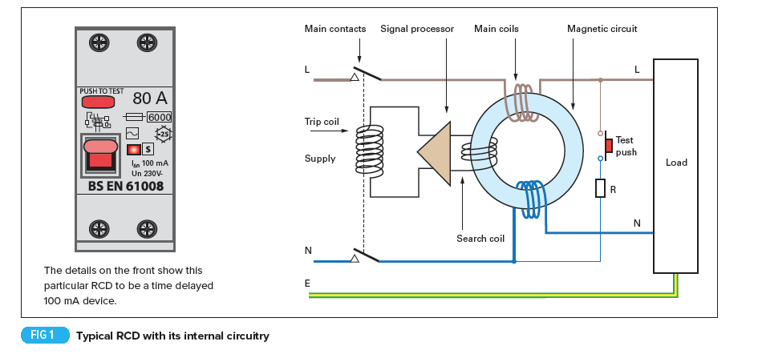RCDs use toroid core upon which the load current (live) and return current (neutral) conductors are wound in opposite directions, along with a detecting winding. In absence of an earth fault, the theoretical sum of the currents is equal to zero. In the presence of an earth fault, there is a difference between the load and return currents which generates a resultant flux in the toroid and induces a current in the detecting winding.

The detecting winding’s current operates a relay, which opens the main contacts of the RCD. The tripping mechanism is operated using two alternative methods (Electromagnetic & Electronic), both offer very reliable performance. Electromagnetic devices use a very sensitive toroid, which operates the trip relay when it detects very small residual currents. Electronic devices do not need such a sensitive toroid as electronic circuits within the device amplify the signal to operate the trip relay.

## Types of Residual Current Devices

RCDs can help protect you from electric shock in potentially dangerous areas and there are various types of RCDs that can be used to make sure you are always as safe as possible.

### RCCB (Residual Current Circuit Breaker)

The **RCCB** detects a current difference between the live and neutral conductors.  This current is known as a residual current. Correctly functioning circuits will always have balanced live and neutral currents. Residual currents are present when there is a fault or potential shock hazard. The current imbalance is usually detected by directing the current path for both the live and neutral conductors to wrap around a toroidal transformer contained within the RCCB body.  The generated magnetic flux is directly proportional to the current drawn through either the live or neutral conductors. The windings are constructed so the live and neutral currents induce magnetic fields in opposite directions. The balanced magnetic fields cancel each other out, making a net zero magnetic flux within the toroid. A small difference in current will result in a net magnetic flux greater than zero. When the net flux is proportional to the leakage current trigger point, the unit will trip out.

### RCBO (Residual Current Breaker with Overload)

It is a combination of a residual current device and a miniature circuit breaker in one package. When a current leakage fault occurs, the internal residual current detecting element will trip the whole circuit. Also, if the circuit is overloaded the internal thermal or magnetic circuit breaker parts are able to trip the circuit in the same way.

### ELCB (Earth Leakage Circuit Breaker)

ELCB is a voltage operated type. It was used to detect any voltage difference between the earth and neutral, indicating that there was a current flowing into the earth being monitored. Voltage ELCBs were widely used in the past and many are still in operation but are no longer used in new installations.

## Sensitivity

RCDs have a wide range of operation. For every RCD there is normally a choice of residual current sensitivity (tripping current). This defines the level of protection afforded.

* High sensitivity: 5, 10, 30 mA (for direct-contact or life injury protection),
* Medium sensitivity: 100, 300, 500, 1000 mA (for fire protection),
* Low sensitivity: 3, 10, 30 A (typically for protection of machine).

As the sensitivity of RCDs increases, their cost accordingly increases.

## Limitations

RCDs will not protect against all instances of electric shock. If a person comes into contact with both the live and neutral conductors while handling faulty parts of an electrical installation, this contact will not be detected by the RCD unless there is a contact between the person and the ground, as some current may still pass through the person’s body to earth. RCDs cannot detect overload conditions, phase-to-neutral short circuits, phase-to-phase short circuits or loss of PEN conductor in TN-C systems. In these cases, over-current protection devices (fuses or circuit breakers) must be provided.

## Importance in electrical circuits

RCDs should operate within 25–40 milliseconds with any leakage currents (through a person) of greater than 30 mA, before electric shock can drive the heart into [ventricular fibrillation](https://en.wikipedia.org/wiki/Ventricular_fibrillation) (the most common cause of death through electric shock).

## Applications of Residual Current Devices

RCDs are used for protection against direct and indirect contacts. They are used in many different installations that require protection such as: Construction sites, Agricultural and horticultural premises, Conducting locations with restricted movement, Caravan and camping parks, Exhibition shows and stands, Outdoor lighting, Marinas, Medical locations, Solar Photovoltaic system power supplies, Mobile or transportable units, Electric vehicle charging installations, Floor and ceiling heating systems.

## Installation types

There are various types of RCDs that can be used to ensure person’s safety.

### Fixed RCDs

These are installed in the consumer unit (fuse box) and can provide protection to individual or groups of circuits. A fixed RCD provides the highest level of protection as it protects all the wiring and the sockets in a circuit, and any connected appliances.

### Socket-Outlet RCDs

These are special socket-outlets with an RCD built into them which can be used in place of a standard socket-outlet. This type of RCD provides protection only to the person in contact with equipment, including its lead, plugged into the special socket-outlet.

### Portable RCDs

These plug into any standard socket-outlet. An appliance can then be plugged into the RCD. They are useful when neither fixed nor socket-outlet RCDs are available but, as with socket-outlet RCDs, they provide protection only to the person in contact with the equipment, including its lead, plugged into the portable RCD.

## Installation considerations

* To check installations, including the functioning of the RCD, during commissioning.
* To regularly verify installations, electrical loads and electrical equipment including RCD equipment during the installation life and to replace failing loads and electrical equipment including RCDs.
* To consider replacing loads or equipment, including RCDs, after a certain number of years depending on the conditions of use or installation.

## Selection table

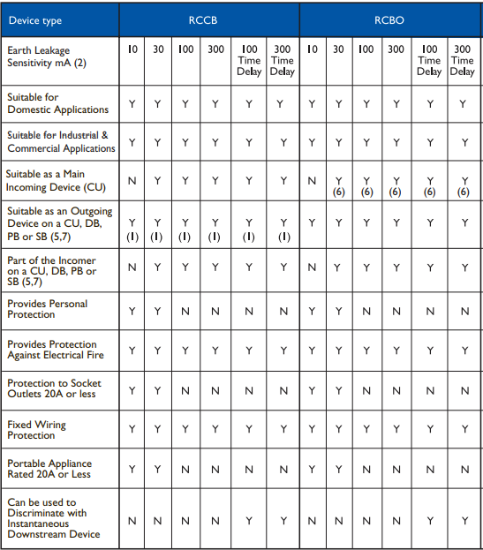

# **Conclusion**

Electric circuit protection devices are the most effective devices which are used for the protection of different circuits. The report identified that all these instruments have the large value for the protection of electrical circuits. Different industries use the devices for reducing the overall ratio of occurrence of hazardous conditions.

The selection of the safety devices should be done carefully to mitigate the faults. All of the devices mentioned are available in several versions that have different characteristics. It is necessary to match the characteristics of the device chosen with the required application.

# **References**

* <https://ieeexplore.ieee.org/abstract/document/1351184>
* <https://electricalfundablog.com/fuse-features-types/#Features_of_a_Fuse>
* https://springltd.co/blog/70/the-importance-of-fuses
* <https://circuitdigest.com/tutorial/fuse-types-and-working>
* <https://www.electronicshub.org/>
* [current-limiting-circuit-breaker-pa01213001e.pdf (eaton.com)](https://www.eaton.com/content/dam/eaton/products/electrical-circuit-protection/molded-case-circuit-breakers/current-limiting-circuit-breaker-pa01213001e.pdf)
* [Circuit Breaker - How it Works, Types, Applications and Advantages (electricalfundablog.com)](https://electricalfundablog.com/circuit-breaker-works-types-applications/#4_Applications_of_Circuit_Breaker)
* [Selection of a circuit-breaker - Electrical Installation Guide (electrical-installation.org)](https://www.electrical-installation.org/enwiki/Selection_of_a_circuit-breaker)
* [How to Size a Circuit Breaker | Hunker](https://www.hunker.com/12291117/how-to-size-a-circuit-breaker)
* [How to Find the Proper Size of Circuit Breaker? CB Calculator (electricaltechnology.org)](https://www.electricaltechnology.org/2020/02/calculate-circuit-breaker-size.html)
* [Understanding Your Breaker Box | White's Electrical](https://www.whiteselectrical.com/blog-post/understanding-breaker-box/)
* <https://www.sciencedirect.com/topics/engineering/residual-current-device>
* <https://www.voltimum.co.uk/articles/rcds-and-18th-edition>
* <https://professional-electrician.com/18th-edition/rcds-operation-application-explained/>
* <https://www.electrical4u.com/residual-current-circuit-breaker/>
* <https://www.electricalengineeringtoolbox.com/2016/01/how-residual-current-device-rcd-works.html>